Provide a Concise and Clear Title, up to 30 words
First Author¹, Second Author², Third Author³
¹ Full affiliation information
Postal Address
E-mail address

² Full affiliation information
Postal Address
E-mail address

³ Full affiliation information
Postal Address
E-mail address
Abstract. The abstract should summarize the contents of the paper and should contain between 150 and 300 words maximum. It should include: i) the purpose of the research, its scope and objective; ii) a review of the relevant literature; iii) the methodology and methods used; iv) major findings/results; and v) a conclusion, summarizing the main ideas of the work. Non-standard or uncommon abbreviations should be avoided, but if essential they must be defined at their first mention in the abstract itself. The abstract and keywords sections should be formatted using the “Abstract and Keywords” style.
Keywords: Provide three to five keywords, separated by commas. These keywords will be used for indexing purposes.

Introduction (Heading 1)
This document may be used as a template, as it already defines the components of your paper (title, author information, abstract and keywords, text, and headings). All text should be formatted using styles, which are available from the Styles section in the Home tab in Word. Styles used in this document include “Title”, “Author Names”, “Author Affiliation Info”, “Abstract and Keywords”, “Heading 1”, “Heading 2”, “Heading 3”, and “Caption”.
Kindly send the final and checked PDF file through the submission system. Every detail, including the order of the names of the authors, should be checked before the paper is submitted. The full paper (including figures, tables, and references) must have a minimum length of six pages and must not exceed eight pages. The language must be clear and comprehensible to a global audience.
The corresponding author is expected to register and pay his/her registration fee during the schedule defined on the ICOTEM Conference webpage (http://icotem23.fam.ulusiada.pt) for the full paper to be included in the technical program of the conference.
The introduction should include sufficient scientific background to understand the rationale and context for the study. This includes a clear description of the research question, research objectives and, where appropriate, specific hypotheses being tested. Grammar, spelling, and accuracy are considered an important screening criterion. If your manuscript contains errors in English, it will be returned. Non-English speaking authors are encouraged to have their manuscript checked and edited by a native English speaker. Alternatively, the use of language editing services can be used to improve a manuscript’s English. Collate acknowledgements, including information on grants received, in a separate section at the end of the article and do not, therefore, include them on the title page, as a footnote to the title or otherwise.

Paper Preparation (Heading 2)
Use the style “Author Names” for the name(s) of the author(s) and the style “Author Affiliation Info” for the affiliation information and addresses. For the abstract and keywords use the style “Abstract and Keywords”. For the main text, the style “Normal” should be used. Italic type may be used to emphasize words in running text. Bold type and underlining should be avoided. Papers not complying with the template will not be accepted.

Headings Format, Tables and Figures
Use the styles “Heading 1”, “Heading 2”, and “Heading 3” for headings. Do not use more than three heading levels. Headings should be capitalized (i.e., nouns, verbs, and all other words except articles, prepositions, and conjunctions should start with a capital letter). Words joined by a hyphen are subject to a special rule. If the first word can stand alone, the second word should be capitalized.
Use the style “Caption” for figures and tables (this is the automatic style if you use the command Insert Caption in the References tab in Word). All figures should have a caption which should always be positioned after the figure. For tables, the caption should always appear before the table. Figure 1 shows an example. All illustrations should be cross-referenced, with the cross reference appearing prior to the illustration in the text (use the command Cross-reference from the References tab in Word).
To ensure that the reproduction of your illustrations is of a reasonable quality, we advise against the use of shading. The contrast should be as pronounced as possible. Thus, figures should be legible and have a resolution of at least 600 dpi (dots per inch).
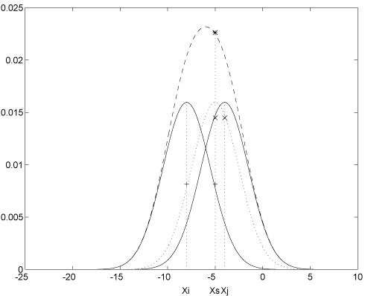
Figure 1. Example of figure caption.
An example of a table formatting is also provided (Table 1). Use a normal and uniform font and no bold or italics for all the words and numbers in tables. Only the first letter of the first word in line one should be capitalized. If the number is larger than 1000, each group of three digits should be separated by a comma. For instance, 1630000 should be written as 1,630,000. Dot should be used as the decimal separator.
Table 1. Example of table caption.

Third Level Heading (Heading 3)
This is an example of a third level heading. As mentioned, do not use more than three heading levels.

Section Two
A paragraph summarising the section content should be included. Thus, text should be added between each two sequential headings.

Formatting Equations
In this section, the guidelines for formatting equations are presented. Number each equation for reference on a separate line and use centre alignment for the equation itself. Numbering should be consecutive within each section or within the contribution, with numbers enclosed in parentheses and set on the right margin (as shown below, which uses a table with two columns with no border). The easiest way to insert a new equation is by selecting and copying the whole table (i.e., both columns) and pasting it to the new location. You can then select the whole text (Ctrl+A) and update the fields by pressing F9. All equations should be cross-referenced, with the cross reference appearing before the equation in the text, in the format “Eq. (1)”.
$$z=x+y$$ | (1)

Citations
The referencing style should be “Springer - Basic (numeric brackets)”. Authors are encouraged to use a reference management system, such as Mendeley® or Endnote®. In-text citations use square brackets and consecutive numbers: [1], [2], [3]. Only references written using the Latin alphabet will be accepted. For further information about this referencing style please check the Springer - Basic (numeric, brackets) Referencing Guide, available at https://citationsy.com/styles/springer-basic-brackets.

Acknowledgements
The information supplied in this section should be kept concise. Should you not need to thank anyone for helping you with your paper, then this section should be removed.

References
1. Bukhsh M, Khan MA, Zaidi IH, (2021) Productivity improvement in textile industry using lean manufacturing practices of 5s & single minute die exchange (Smed). In: Proceedings of the International Conference on Industrial Engineering and Operations Management. pp 7374–7385
2. Schütz K, Kässer M, Blome C, Foerstl K (2020) How to achieve cost savings and strategic performance in purchasing simultaneously: A knowledge-based view. J Purch Supply Manag 26:100534. https://doi.org/10.1016/j.pursup.2019.04.002
3. Abtew M, Selvaduray G (2000) Lead-free Solders in Microelectronics. Mater Sci Eng R Reports 27:95–141. https://doi.org/10.1016/S0927-796X(00)00010-3

Corresponding author

